# JAYPEE INSTITUTE OF INFORMATION TECHNOLOGY, NOIDA

B. TECH III SEMESTER PROJECT REPORT



Submitted by Group:

|  |  |  |  |
| --- | --- | --- | --- |
| **S. No.** | **Enrolment No.** | **Name** | **Batch** |
| **1** | 20103001 | Tushar Pasricha | B1 |
| **2** | 20103019 | Sarthak Gupta | B1 |
| **3** | 20103028 | Bhavey Mittal | B1 |
| **4** | 20103029 | Naman Gupta | B1 |

**GROUP-2**

# Under the Supervision of:

DR. ADITI SHARMA

Department of DSW

JIIT, Sector 62, Noida

Project Title:

ShopXSocial–shopping & selling made easy.

Project Overview:

ShopXsocial aims at providing the features of an e-commerce website and social media altogether

Beginning:

At the first page the user is provided with two options i.e., to login or signup, in the signup page user can signup either as a seller or as a buyer.

Customer View:

When the user logins/signup as a customer/buyer he will be directed to the page where all the shops are visible and the customer can enter any shop and have a look of all the products of the entered shop and could view the description of any product and request the details of that product from the Owner of the Shop.

Seller View:

When the user logins/signup as a seller after creating his shop/or the shop being already existing then he will be able to see all the products of his/her shop and also being provided to add products to his shop and can edit any details about any product. Apart from this the seller is also able to see the newsfeed in which the posts of all other sellers along with his own are visible.

Assumptions:   
Buyer- seller will handle the transportation on their end and they will deal in wholesale only (Products are to be sold in bulk).

Applications:

This Webapp provides an interface for buyers and sellers to interact promoting online business and features like newsfeed also makes the user to develop interest, thus sticking to this webapp.

*ERR-MODEL*

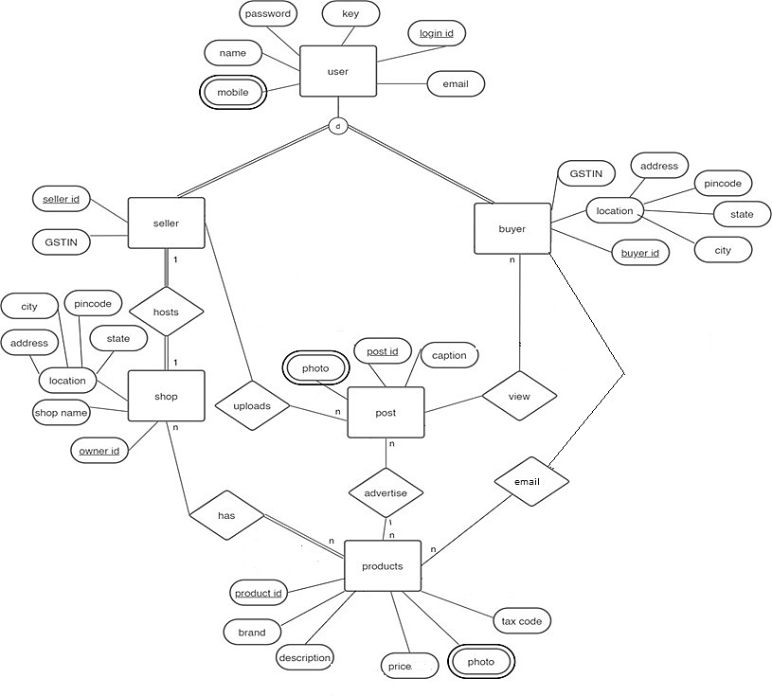

*Screen Shots*

*Home page*

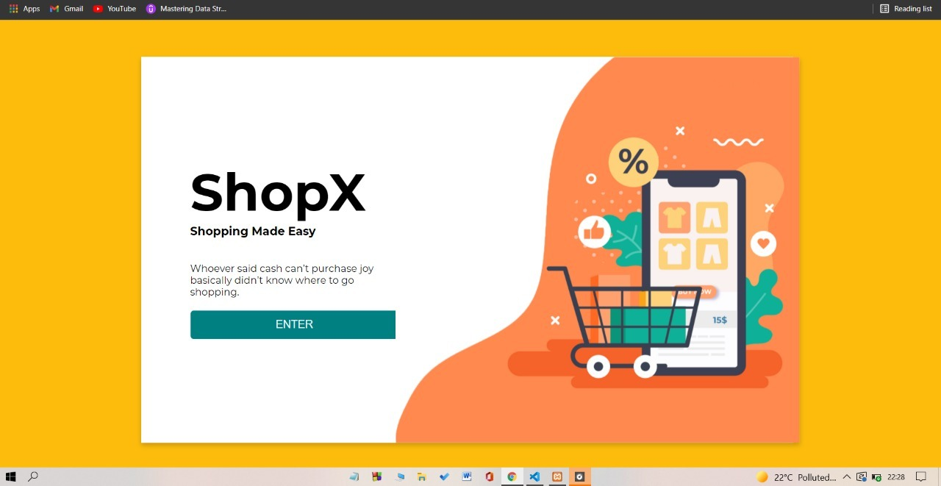

*Login page*

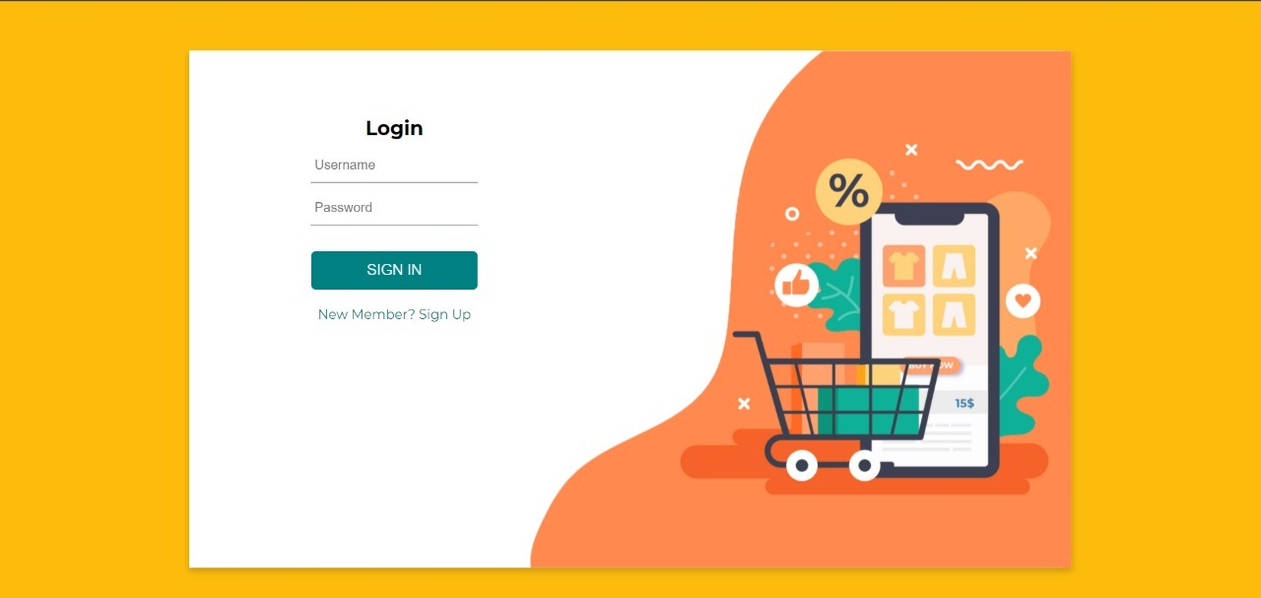

*Sign-Up page*

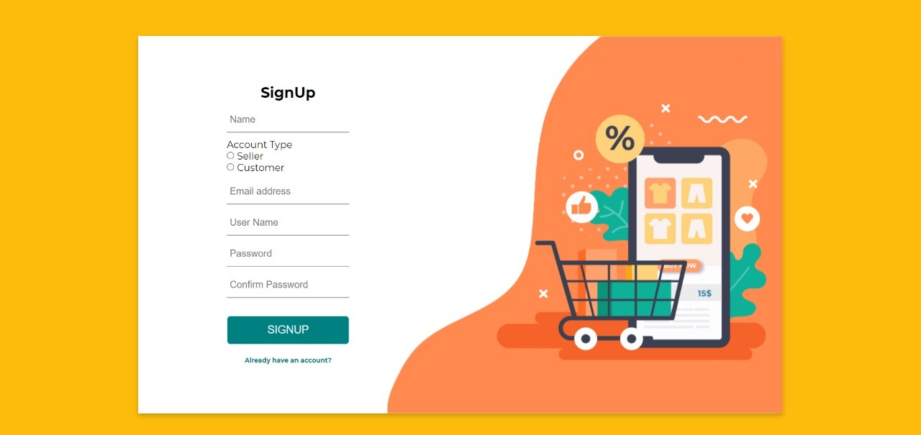

*Customer View*

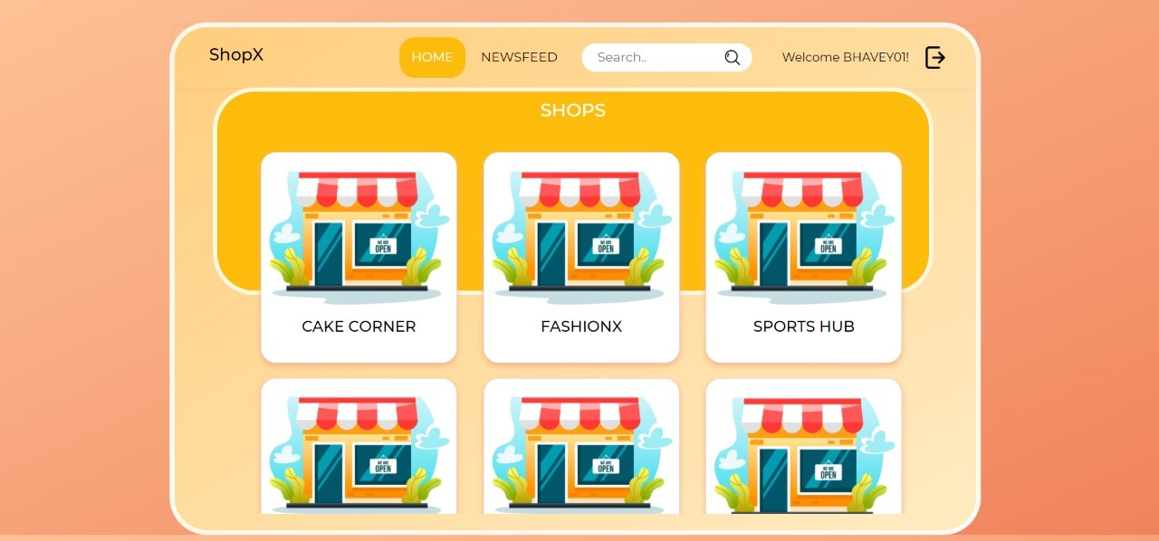



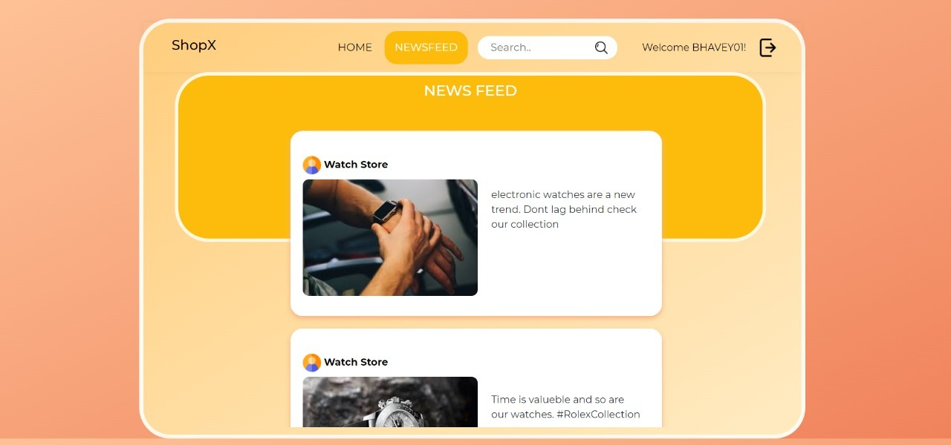

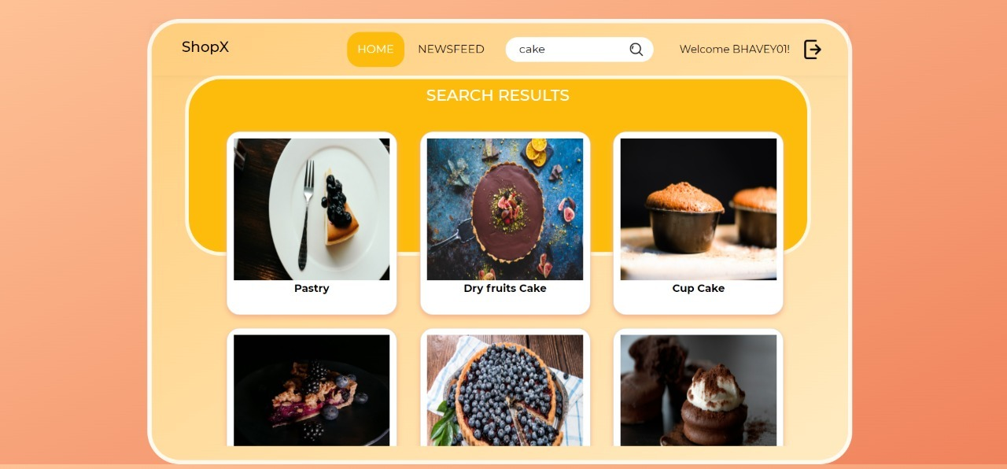

*Seller View*

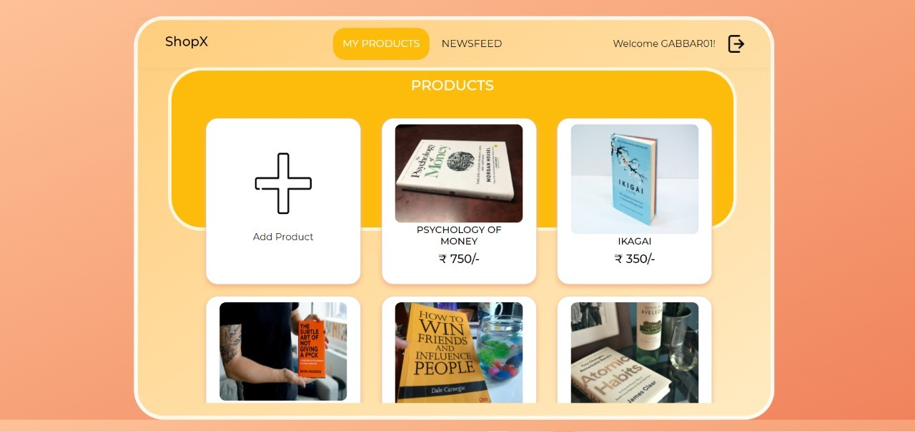

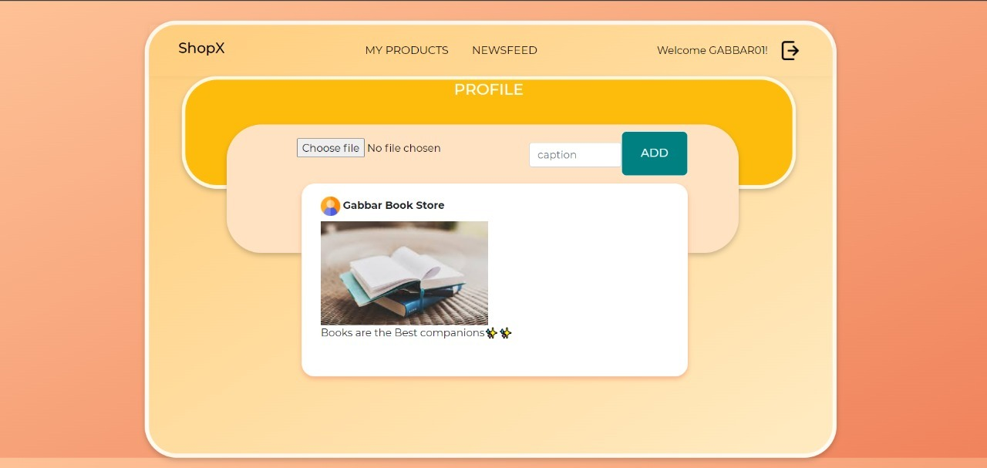

*Mapping*

*Tables :*

*USERS TABLE*

|  |  |  |  |  |  |
| --- | --- | --- | --- | --- | --- |
| *User_id* | *User_name* | *e-mail* | *name* | *password* | *Account type* |

*BUYER TABLE*

|  |  |  |  |  |  |  |
| --- | --- | --- | --- | --- | --- | --- |
| *Login Id* | *Buyer Id* | *GSTIN* | *State* | *City* | *Pincode* | *Address* |

*Products*

|  |  |  |  |  |  |  |
| --- | --- | --- | --- | --- | --- | --- |
| *Prod id* | *Shop_id* | *Product_desc* | *Product_title* | *price* | *Status* | *Image* |

*Shop*

|  |  |  |  |  |  |  |  |
| --- | --- | --- | --- | --- | --- | --- | --- |
| *Shop_id* | *Shop_name* | *Owner_id* | *City* | *Pincode* | *Address* | *GSt_in* | *State* |

*Post*

|  |  |  |  |
| --- | --- | --- | --- |
| *Post id* | *caption* | *photo* | *User_id* |

*Github Repository*

[*https://github.com/tusharpasricha/ShopX*](https://github.com/tusharpasricha/ShopX)